Experience of Using OpenROAD Flow Scripts on a Specific Design

Ajay chopra

Agasthya App labs

Ex mirafra technologies

Student DTU and Amity

Abstract: The QRFS is a tool developed by university

California San Diego in collaboration with VSD Team

Bangalore. The tool is opensource and any one can use it.

positives of the tool are Open road has integrated tools for

Physical design and STA no need to use different tools for

Physical design and STA, other positive is that fast turn around time less than 24 hours for 7nm designs and Complete openroad Tool takes less than 20GB space and it can also work on number of platforms. The negative of open road flow script is that

1)Openroad tool places standard cells randomly and they are not in the Grid there could be an enhancement in which we will placing the standard cell adjacent to each other in sequential manner that will improve the timing .

1.INTRODUCTION

Open road flow script is open-source flow which is used to be cost effective and less time consuming. The advantage is that it can work on Advance node as well and number of tape outs has been done. This tool is from RTL to GDSII. The disadvantage which I saw was

Regarding the makefile we will discuss that in detail below. In this paper we will discuss the pros and cons of the ORFS and Tell our experience regarding the ORFS .

2. DESIGN FLOW OVERVIEW

OPENROAD tool is complete RTL to GDSII tool with number of stages Integrated in one particular flow. Like make file has synth, Floorplan, Placement, CTS, routing and finish. For one of the blocks ASAP7 UART it takes less than 5 mins to run complete RTL to GDSII. The flow is setup with the make file approach as it is easy to run the flow continuously.

The disadvantages which I can see are mentioned below

1) Openroad tool places standard cells randomly(i.e figure 1) and they are not in the Grid there could be an enhancement in which we will placing the standard cell adjacent to each other in sequential manner that will improve the timing ..

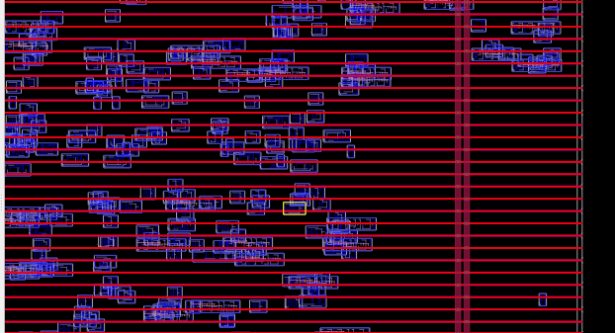

Figure 1 OPEN ROAD TOOL Standard cell placement

Figure 2 shows how standard cells placed in order

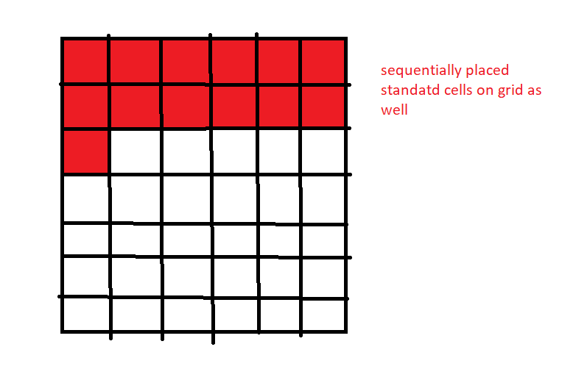

Figure 2 standard cells placed properly in a order

3.CONCLUSION OR RESULT

OPENROAD tool is complete RTL to GDSII tool the overall experience is positive

1.It can run on number of designs from 45 nm to 7 nm.

2.Over all run time is good.

3. It has good run time for lower nodes as well.

4. It has a makefile flow.

5.Installation takes less the 20 GB

6. It can run on number of platforms.

The disadvantage or negative which I found out is mentioned below.

1) Openroad tool places standard cells randomly and they are not in the Grid there could be an enhancement in which we will placing the standard cell adjacent to each other in sequential manner that will improve the timing .

4.REFERENCES

1.Openroad 7nm physical design contest ,VSD 22feb 2023 <https://www.openroaddesigncontest.org/>

2.OpenRoad flow scripts .Github https://github.com/The-OpenROAD-Project/OpenROAD-flow-scripts